|  |  |  |  |  |  |  |  |  |  |  |
| --- | --- | --- | --- | --- | --- | --- | --- | --- | --- | --- |
| **Customer experience journey map**  **Customer experience journey map**  Use this framework to better understand customer needs, motivations, and obstacles by illustrating a key scenario or process from start to finish.  When possible, use this map to document and summarize interviews and observations with real people rather than relying on your hunches or assumptions.  Created in partnership with  [**Share template feedback**](https://muralco.typeform.com/to/CiqaHVat?typeform-source=app.mural.co) | |  | ✴  **Document an existing experience**  Narrow your focus to a specific scenario or process within an existing product **TIP**  or service. In the **Steps** row, document the step-by-step process someone As you add steps to the  typically experiences, then add detail to each of the other rows. experience, move each these  “Five Es” the left or right  depending on the scenario you are documenting. | | | | | | | |
|  | **SCENARIO**  **Browsing, booking, attending, and rating a local city tour** | **Entice**  How does someone initially become aware of this process? | **Enter**  What do people experience as they begin the process? | **Engage**  In the core moments in the process, what happens? | **Exit**  What do people typically experience  as the process finishes? | **Extend**  What happens after the experience is over? |  |
| **Steps**  What does the person (or group) typically experience? | **Discover new Make them**  **products aware**  **Inspire customers** | **Help them Product**  **decide information** | **Demand Support the Sell them**  **opinions customers the product** | **Makes the payment for preferred product** | **Share experiences** |
| **Interactions**  What interactions do they have at each step along the way?  **People:** Who do they see or talk to?  **Places:** Where are they?  **Things:** What digital touchpoints or physical objects would they use? | **customers receives Customers sees a fashion advices on new dresses on dresses from smart fashion**  **fashion recommender** | **Customers can see price,colors and sizes online** | **They checks the Customers**  **other dresses for checks the**  **proper product details**  **comparisons**  **Customers Customers checks**  **checks the the loyalty points**  **products and and views local**  **availability offers** | **Makes the order** | **Share experiences with friends on social media** |
| **Goals & motivations**  At each step, what is a person’s primary goal or motivation? (“Help me...” or “Help me avoid...”) | **Increase social Achieve brand**  **following Recognition**  **Review your business plan** | **Increase productivity** | **Target reliable Test new Create new**  **customers and ideas products**  **distributors** | **Attainable**  **Relevant** | **Reach out to a customers needs** |
| **Positive moments**  What steps does a typical person find enjoyable, productive, fun, motivating, delightful, or exciting? | **Happy as the customers finds numerous products** | **Happy and excited!!!** | **Clear and Suprise to Happy with the**  **innovative see lots of informative**  **design discounts** | **Excited to Happy to see give a suprise many options to the friend** | **More user friendly** |
| **Negative moments**  What steps does a typical person find frustrating, confusing, angering, costly, or time-consuming? | **Confusing about how to choose** | **Annoyed at the useless info** | **Frustrated about Sad to see**  **reviews from out of stock**  **other customers products** | **Not sure about how to find the best price** | **Feels unhappy to wait for a bit longtime** |
| **Areas of opportunity**  How might we make each step better? What ideas do we have? What have others suggested? | **Increase shooping Increase**  **cart customer**  **value&conversation**  **rate satisfaction** | **Make products to match expectations** | **online Increase satisfy customer needs and**  **development online sales expectations through services** | **Target marketting,make re-ordering easy** | **Develop Manage**  **sharing feedback and**  **social media** |
|  |  |  |  | | | | | | | |
|  | **Need some inspiration?**  See a finished version of this template to kickstart your work.  [**Open example**](https://app.mural.co/template/f59f644b-b4b4-47b5-9ed6-3a8c71ceb612/896b31fe-5597-40ef-9b06-3811a1a45ace) |

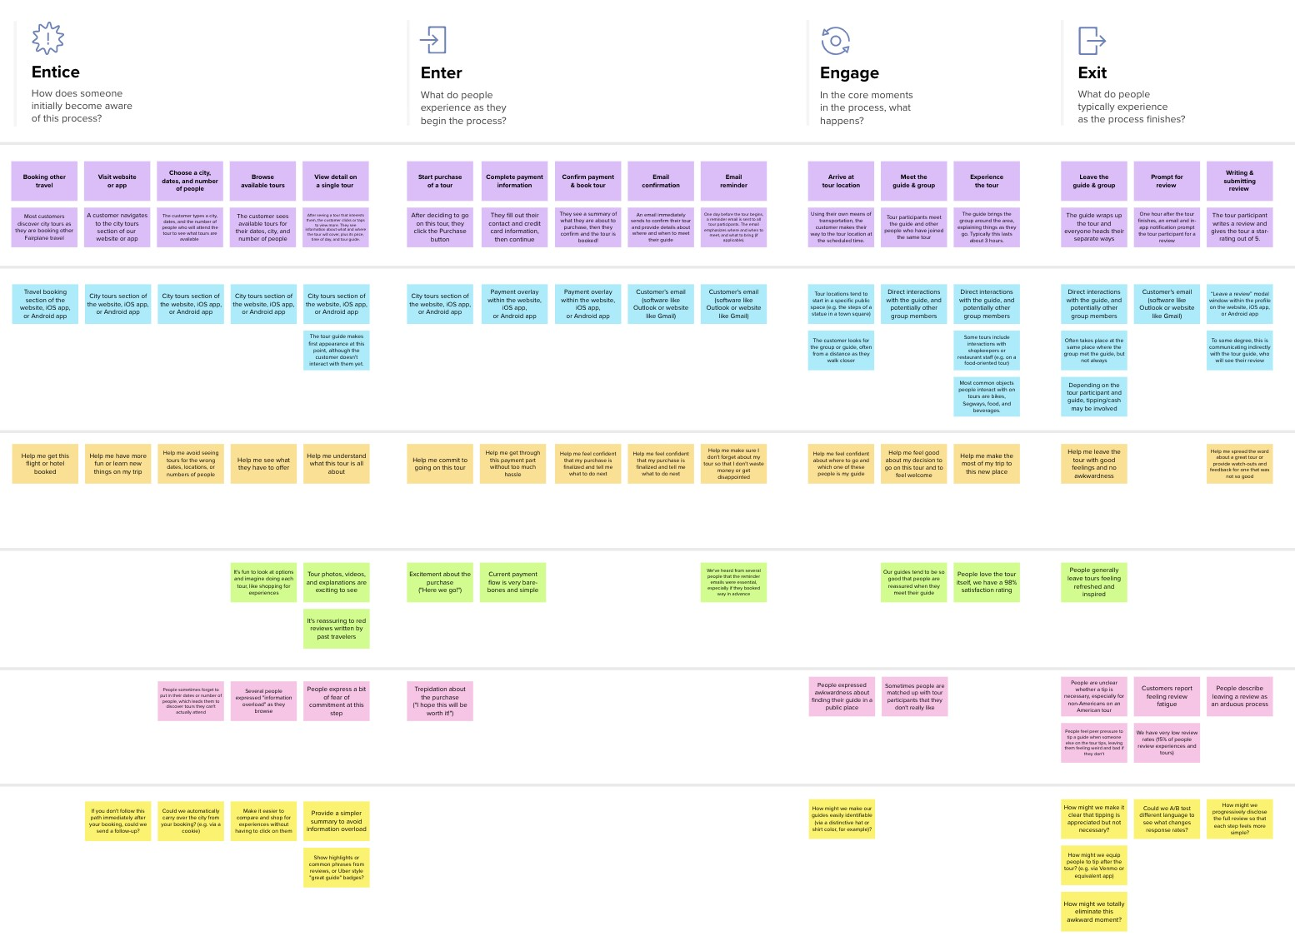

Template

